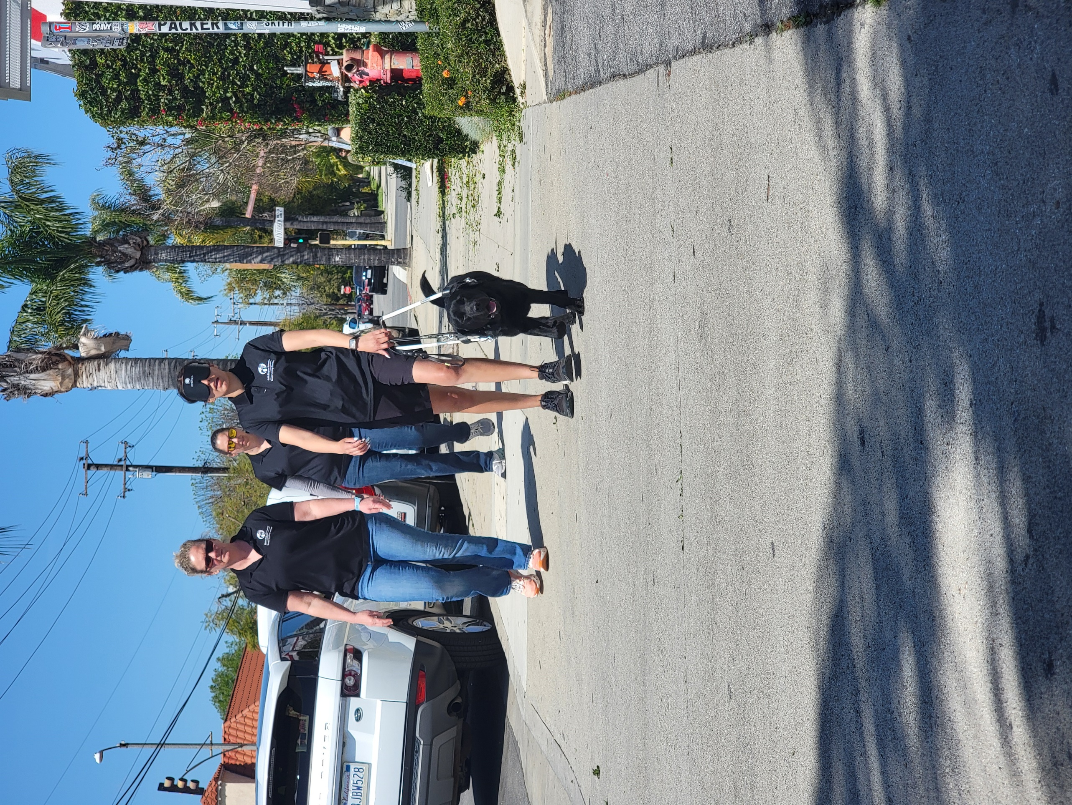

Hi Family!

It’s me again from Guide Dog College. Hope you are doing well. I have some exciting news! I passed my preliminary test! It’s the first of many more tests, but I’m excited. I got to guide my instructor around while she wore a blindfold. I crossed streets safely, stop for curbs, and made left and right turns. I had fun showing off my new skills. Soon we will be moving into new areas like Burbank, Pasadena, and Northridge. I’m looking forward to the challenges.
I still get to have fun during the times I’m not out training. I get to play with my friends in the kennels. Miss you, but having an awesome time!

Wags & Kisses,

Whelan

