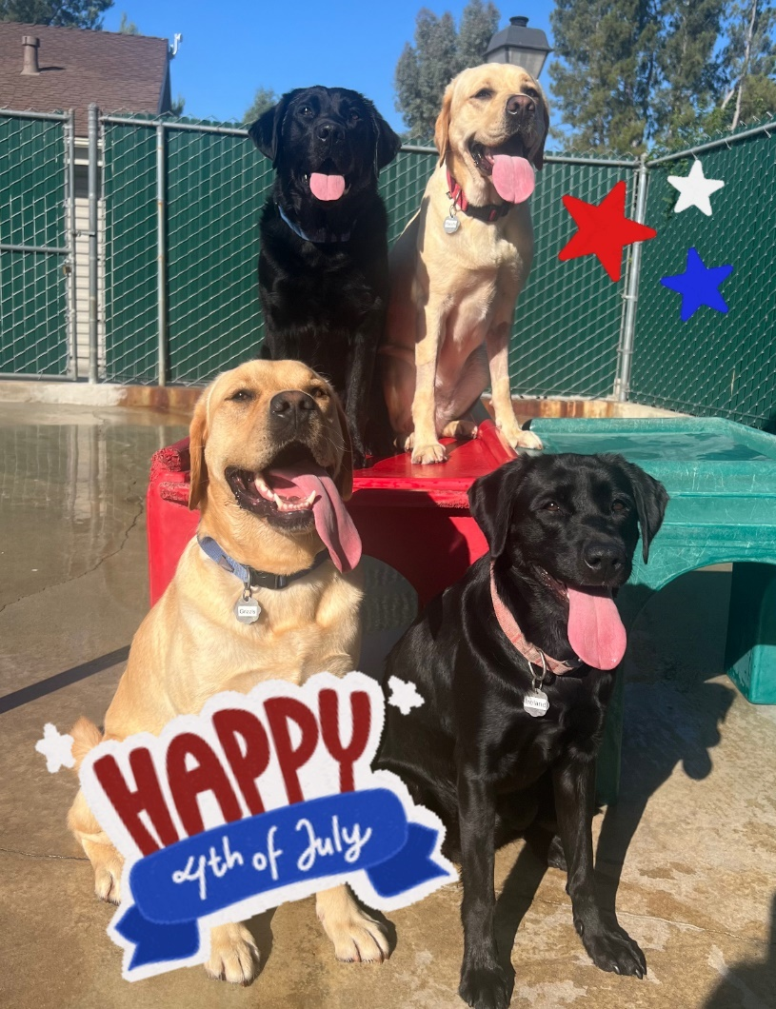
Top Row: Me & Hashi Bottom Row: Grizzly & Ireland

Hi Family, it’s SUMMERTIME, YAY! I’ve been staying busy this past month, but my trainer is making sure that we all are staying cool! With all this warm weather, we have been having pool parties and I love to try to play with the hose. When not playing in the water during community run, my trainer has been keeping my mind sharp with guide work in Burbank, Valenica and Northridge. My trainer told me that this week is the Fourth of July! Happy Independence Day! I miss you but I am doing great here at doggie college!
Wags & Kisses,
Whelan


