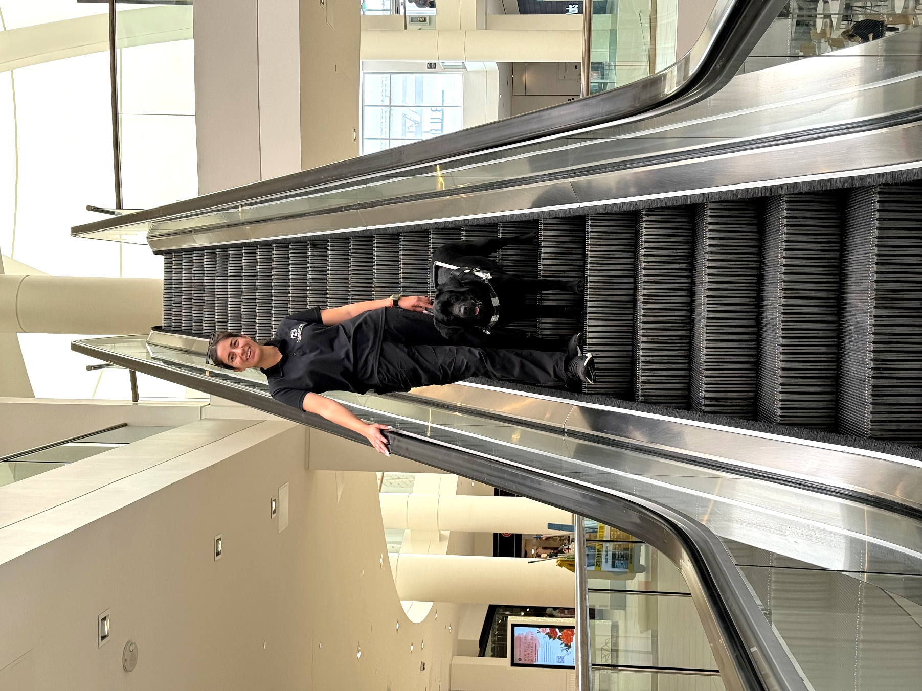

Hi Family,
How are you? Everything is going well at guide dog college. She worked with me on travelling safely around traffic to prepare me for my next test around traffic. And, I finally learned how to travel on escalators. Boy, are those things fun after I got the hang of it. I know how to find escalators, elevators, doors, and stairs for my instructor. I love it when she gets so excited when I find things for her. Still working in Burbank mostly. The smells out there are amazing! Oh, and so many different looking dogs. But I am working very hard not to let all that distract me no matter how hard it is sometimes.

My roommate and I have a lot of fun together when we aren’t working. The Training Department Volunteers are cool too because they spend extra time with us when we get time off from training. Well, better get back to my studies. Miss you but have a good time!

Wag & Kisses,

Whelan

