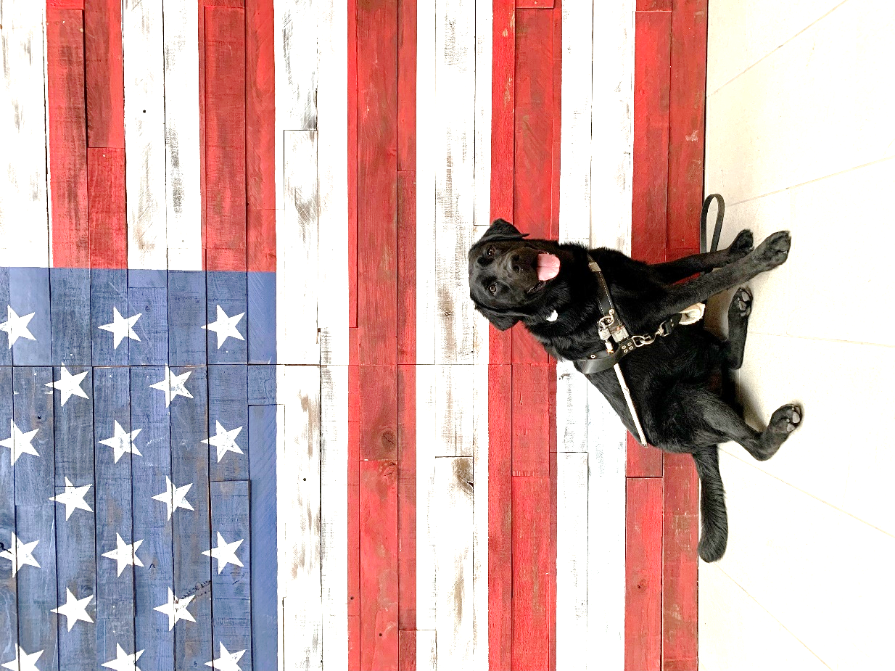

Hi Family,
We have made it to September! My trainers keep singing some song about September 21^{st,} and I keep trying to tell them that I don’t remember the 21st of September… Oh well. They seem to have fun signing about it so much, that it must have been a great day of training us pups! I worked really hard to keep my guide skills sharp while my friends were up in class. We have another class coming up next month and my paws are crossed that I will be matched with my forever human. I miss you all but am doing great here at doggie college!
Wags & Kisses,

Whelan

